Practical Record File

Submitted for :

Artificial Intelligence

|  |  |  |
| --- | --- | --- |
| Submitted by :  Aayush Dhande  Class: **9E** |  | Submitted to:  Priyadarshini Sadhu |

Certificate

|  |  |  |
| --- | --- | --- |
| Class : IX E |  | Subject : Artificial Intelligence |
|  |  |  |
|  |  | Subject Code : 402 |
|  |  |  |

This is to certify that this Project/Assignment/Activity is the work of

Kumar : Aayush Dhande

|  |  |  |
| --- | --- | --- |
| Registration No. |  | Board Exam Roll No. |

He has completed the project under my supervision. He has taken proper care and shown utmost sincerity in completion of this Project/Assignment/Activity.

I certify that, this Project/Assignment/Activity is up to my expectation and as per the guidelines issued by CBSE.

External Examiner Principal Internal Examiner Stamp

(Signature) (Signature)

___________ __________

Acknowledgements

I would like to express my special thanks to Dr. Amrita Vohra, Segment Head Mrs. Reshmi Sinha and my Teacher Mrs. Priyadarshini Sadhu whose valuable guidance has helped me patch this project and make it a full-proof success. Her suggestions and instructions have served as the major contributors towards the completion of this project. I would also like to thank the Artificial Intelligence department of Elpro International School and my parent’s constant support throughout the year which helped me complete the project.

INDEX

|  |  |  |
| --- | --- | --- |
| **Sr. No.** | **Program** | **Page No.** |
| 1. | Python | 5 |
| 2. | Practical 1: P**rogram to print all the elements of a list** | 6 |
| 3. | Practical 2: P**rogram to add any value to a given list by sdasdasdaaspecific index position.** | 7 |
| 4. | Practical 3: P**rogram to remove any element of a list by fdfG entering index.** | 8 |
| 5. | Practical 4 : P**rogram to print the number of elements asdad which exist in a list.** | 9 |
| 6. | Practical 5 : P**rogram to print the sum of all elements of any asdasd list.** | 10 |
| 7. | Practical 6 : Program to perform operations on a string | 11 |
| 8. | Practical 7 : Program to perform operations on a list | 12 |
| 9. | Practical 8 : Program to add two integers | 13 |
| 10. | Practical 9 : Program to find area and perimeter of a ssassad rectangle | 14 |
| 11. | Practical 10 : Program to find greatest of three numbers | 15 |

Python

Practical **1**

**Topic : Write a program to print all the elements of a list**

**Code:**

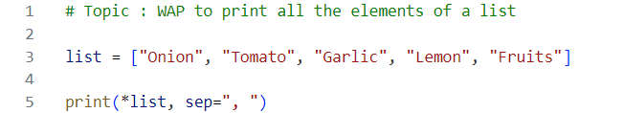

**Output :**



**Practical 2**

**Topic : Write a program to add any value to a given list by specific index position.**

**Code :**

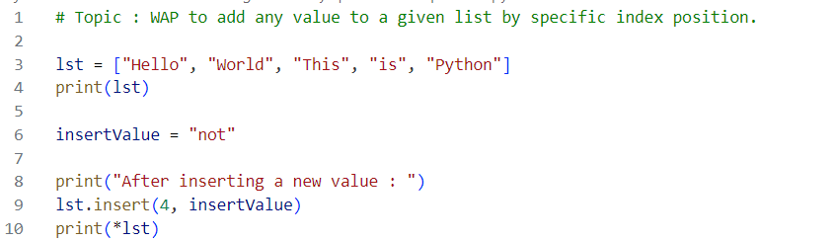

**Output :**

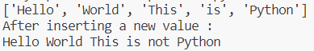

**Practical 3**

**Topic : Write a program to remove any element of a list by entering index.**

**Code :**

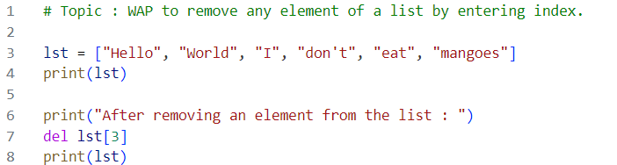

**Output:**



**Practical 4**

**Topic : Write a program to print the number of elements which exist in a list.**

**Code :**

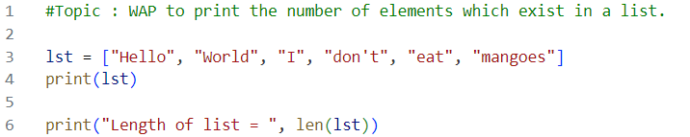

**Output :**



**Practical 5**

**Topic : Write a program to print the sum of all elements of any list.**

**Code :**

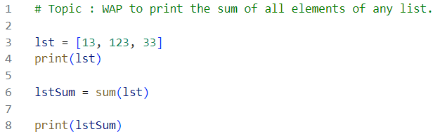

**Output :**



**Practical 6**

**Topic : Write a program** **to perform the following operations on the given string: "Python is an interpreted, high-level and general-purpose programming language."**

**a) Find the length of the string.**

**b) Find the word "and" and replace it with symbol "&".**

**c) Join the string with the text "It has a simple syntax similar to the English language.**

**Code :**

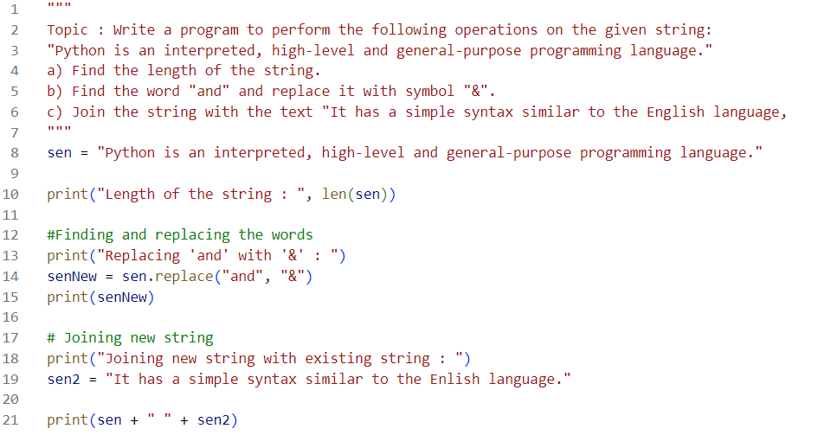

**Output :**



**Practical 7**

**Topic : Write a program to perform the following operations on the given list:**

**('Orange', 'Mango', 'Papaya', 'Apple', 'Grapes')**

**a) Remove "Papaya" and add "Guava" at the same position.**

**b) Sort the list in ascending order.**

**d) Add the "Cherry, Banana, Coconut" to the list.**

**Code :**

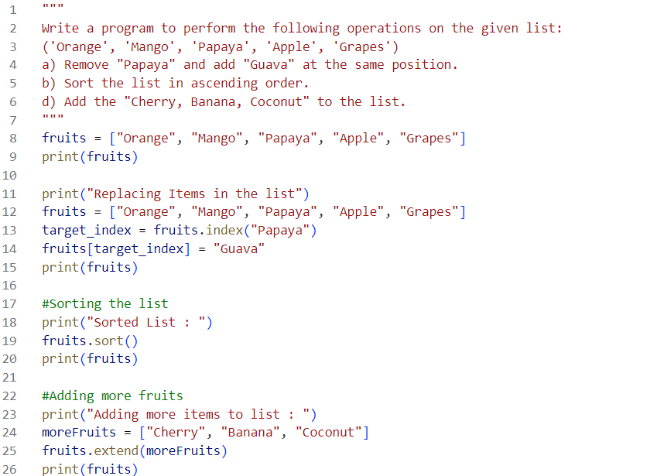

**Output :**

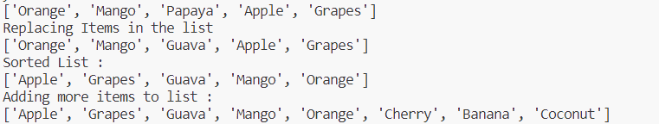

**Practical 8**

**Topic : Write a program to add two integers.**

**Code :**

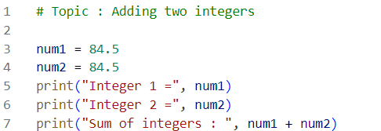

**Output :**



**Practical 9**

**Topic : Write a program to find the area and perimeter of a rectangle using user input.**

**Code :**

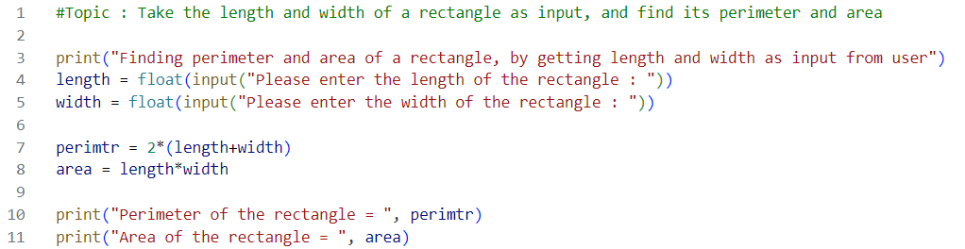

**Output :**

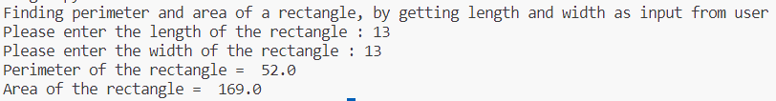

**Practical 10**

**Topic : Write a program to find the greatest of three numbers.**

**Code :**

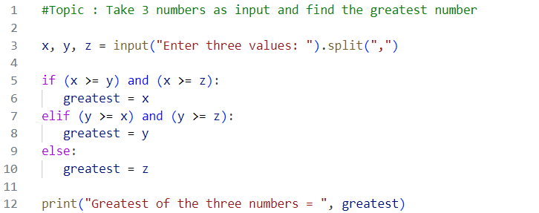

**Output :**

